Sleep and Activity Log Study: _________ Timepoint: ___________ ID:__________
Log Instructions: Please complete this daily log for each day that you wear the activity monitor.
For the monitor, please note the time you wake-up. At the end of each day please note the time you go to sleep (not the time you get in bed). Throughout the day if you must remove your monitor, please note the time(s) you do so and the reason (e.g. showering). Also note any changes from usual activity under the heading marked “notes” (e.g. “sick today, stayed home from work”).
Monitor Instructions:
1. It is easiest to put this monitor on while sitting down. Wipe clean a patch of skin on the front of either leg approximately 6 to 8 inches above the knee (avoid wearing lotion on the area to help the tape adherence).
2. Take one rectangle of the provided Tegaderm tape and place it on a flat surface with the 3M label facing up. Hold onto the short edge of the Tegaderm and peel off this white layer.
3. Place this monitor face down on the Tegaderm tape (so that you cannot see the arrow & number) in the middle of the square.
4. Next, while seated, carefully turn over the Tegaderm tape with the monitor attached and place it on your thigh, about halfway between your hip and knee (as shown below). It should be positioned so that the arrow points upwards toward your waist with the rounded side on top and the flat side on the bottom.
5. Smooth out the tape as much as possible. You will now peel the top, clear layer by pulling from the white tabs in the middle of the tape. Again, smooth out the tape over your leg so that it adheres to your skin as well as possible.
6. Wear the monitor each day and night before your next appointment (i.e. wear all day and while sleeping). You should take this monitor off ONLY when you are swimming or bathing.
***If you become sick or are unable to wear the monitor for 7 days, please contact the research team to research your next appointment at wellexlab@education.wisc.edu or 608-890-0154.
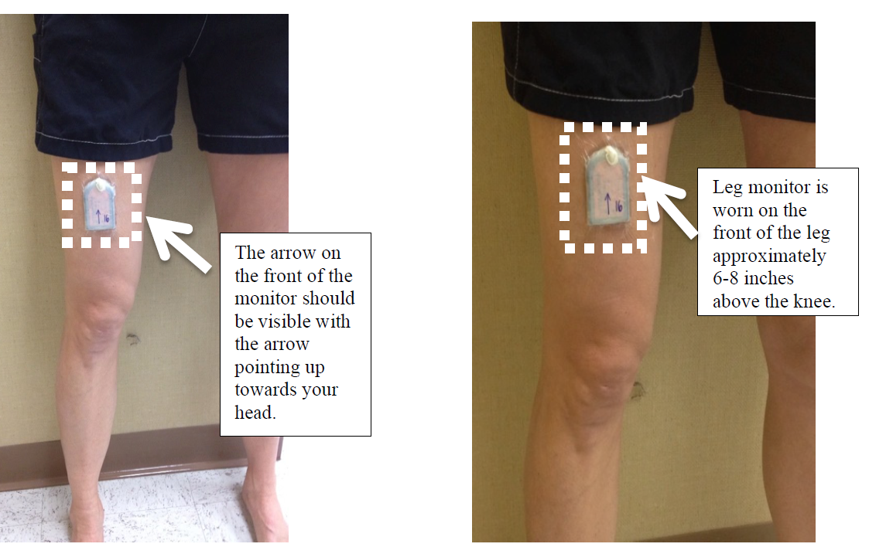
Activity Log
Original Application Date & Time: _______________________________
Final Removal Date & Time: _______________________________

Sleep Log
Day | Date  (e.g. 08/15/2020) | Time Awake  (e.g. 6:30 AM) | Time to Sleep  (e.g. 10:30 PM)
1 | ____/____/____ |  | ____:____ AM/PM
2 | ____/____/____ | ____:____ AM/PM | ____:____ AM/PM
3 | ____/____/____ | ____:____ AM/PM | ____:____ AM/PM
4 | ____/____/____ | ____:____ AM/PM | ____:____ AM/PM
5 | ____/____/____ | ____:____ AM/PM | ____:____ AM/PM
6 | ____/____/____ | ____:____ AM/PM | ____:____ AM/PM
7 | ____/____/____ | ____:____ AM/PM | ____:____ AM/PM
8 | ____/____/____ | ____:____ AM/PM | ____:____ AM/PM

Removal Log (if needed; e.g., swimming, replacing Tegaderm)

Date | Time Period of Removal  Removal Time Application Time |  | Reason for Removal
____/____/____ | ____:____ AM/PM | ____:____ AM/PM
____/____/____ | ____:____ AM/PM | ____:____ AM/PM
____/____/____ | ____:____ AM/PM | ____:____ AM/PM
____/____/____ | ____:____ AM/PM | ____:____ AM/PM
____/____/____ | ____:____ AM/PM | ____:____ AM/PM
____/____/____ | ____:____ AM/PM | ____:____ AM/PM
____/____/____ | ____:____ AM/PM | ____:____ AM/PM
____/____/____ | ____:____ AM/PM | ____:____ AM/PM

